PHASE 8 – DATA MANAGEMENT & DEPLOYMENT
- Data Import Wizard
Data Import Wizard was used to import student records into Salesforce.
Student data was prepared in CSV format
New student records were imported into Student__c object
Lookup field (Course) was linked separately after import
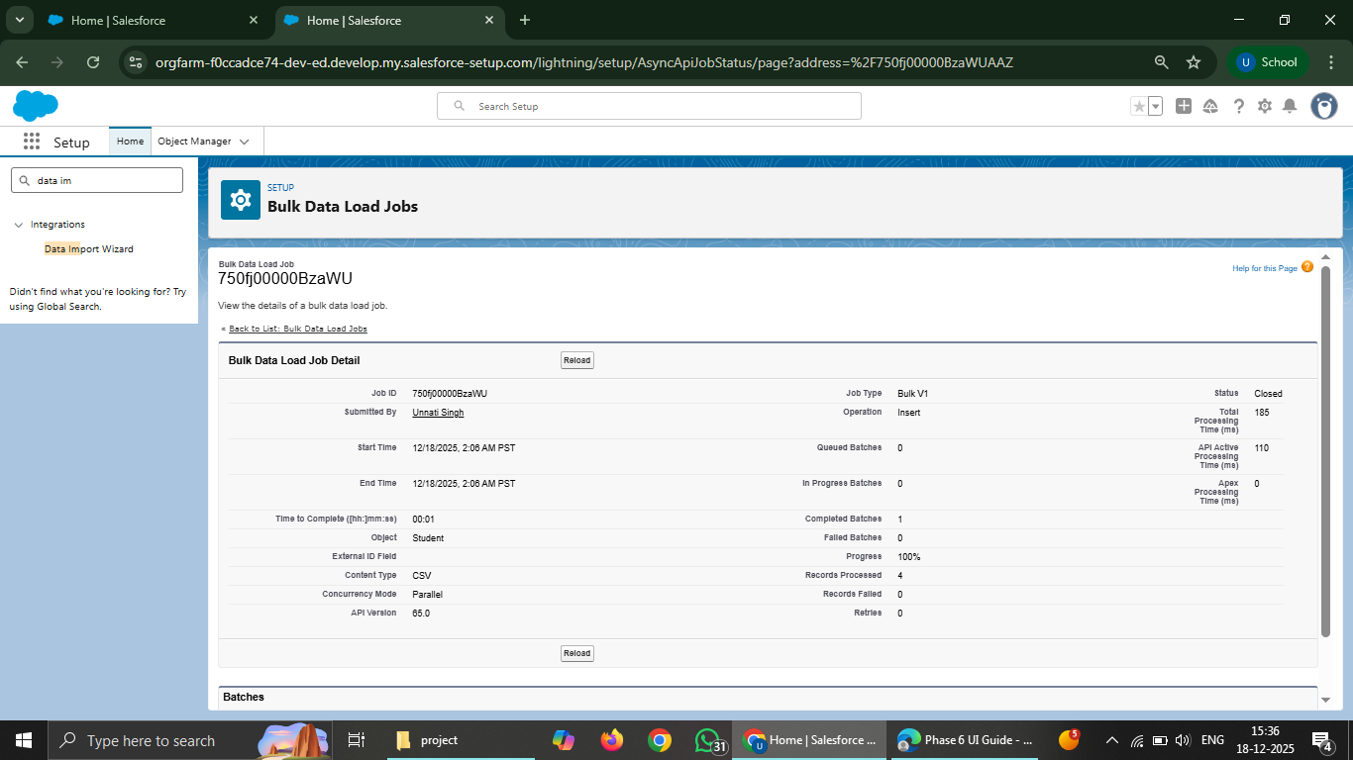

- Course Linking After Import
Since lookup fields are not supported directly by Data Import Wizard:
Student records were imported without Course
Course field was linked manually from the Student record page

- Duplicate Rules
Duplicate management was implemented to avoid duplicate student records.
A Matching Rule was created on Student Email
A Duplicate Rule was configured to block duplicate records on create.
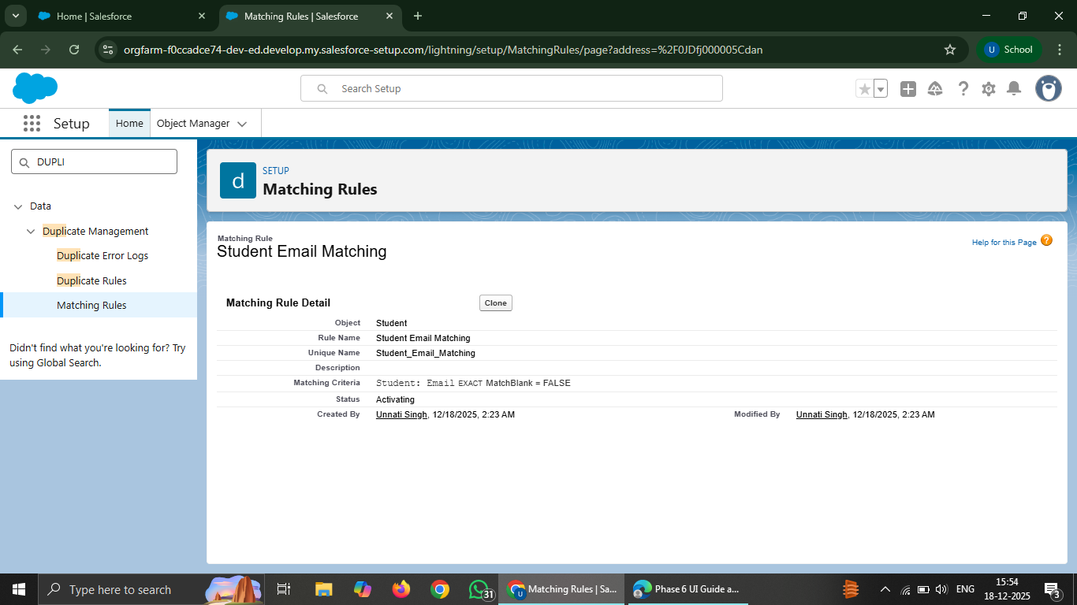

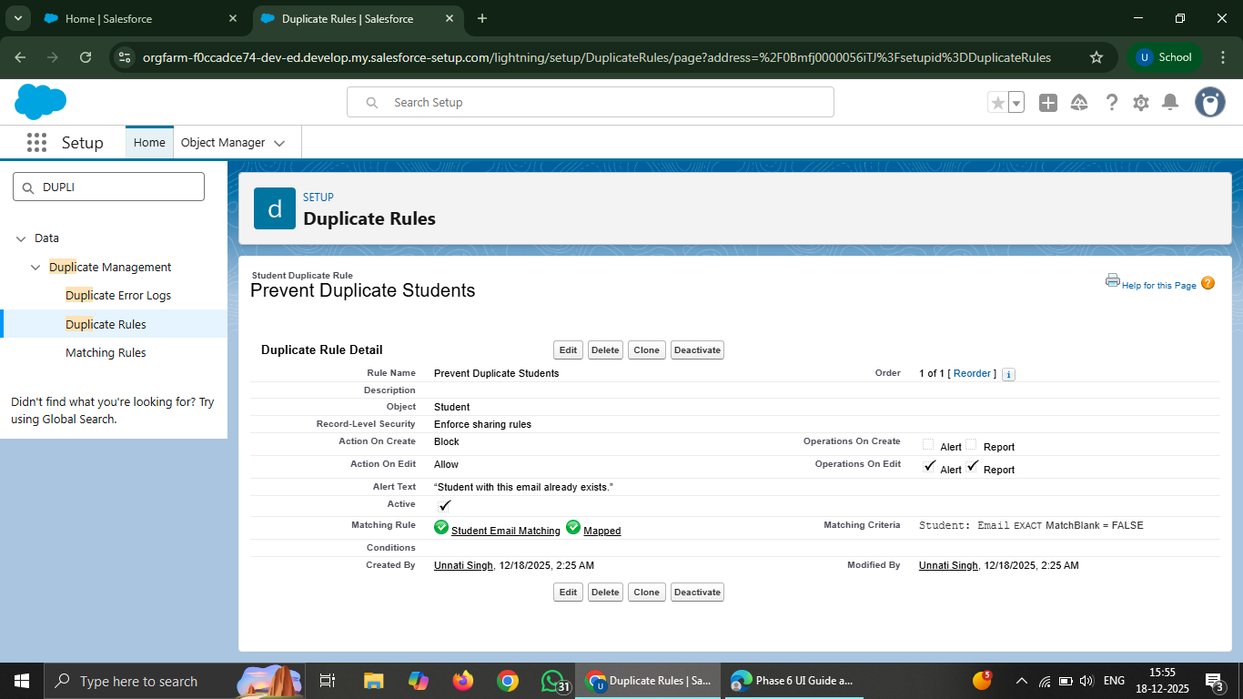

•Data Export & Backup

Salesforce Data Export feature was used to create a backup of project data.
Student, Course, Attendance, and Fees objects were selected
Data was exported in CSV format as a ZIP file.

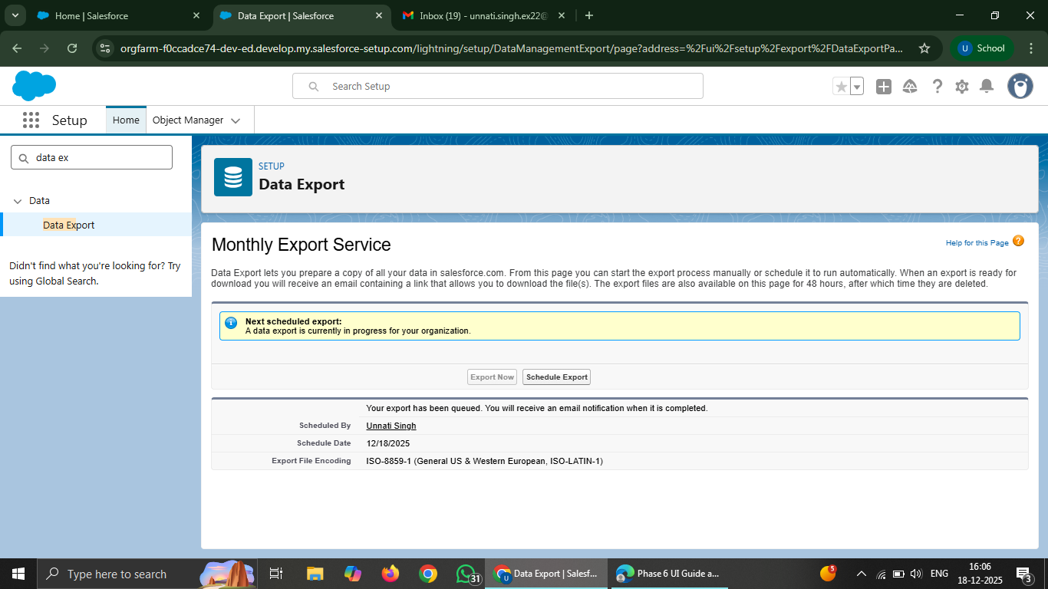

- Change Sets & Deployment Settings
Deployment concepts were studied using Change Sets.
Deployment Settings were reviewed
Since the project was developed in a single Developer org, no actual deployment was performed
- Unmanaged vs Managed Packages
Different types of Salesforce packages were studied.
Unmanaged Package: Used for learning and internal projects
Managed Package: Used for AppExchange and commercial products
- ANT Migration Tool (Conceptual)
ANT Migration Tool was studied as a command-line deployment tool.
Used for metadata deployment
Suitable for CI/CD pipelines
Not required for this learning project
- VS Code & Salesforce DX (SFDX)
Professional development tools were studied.
VS Code is used for writing Apex and LWC
Salesforce DX is used to connect Salesforce org with local system
Helps in version control and modern development practices

